Structural and Behavioural Model
Project Title: AI based Academic Expense & Loan Planner
By
Chaitanya Raj Kolipaka

1. Use Case Diagram
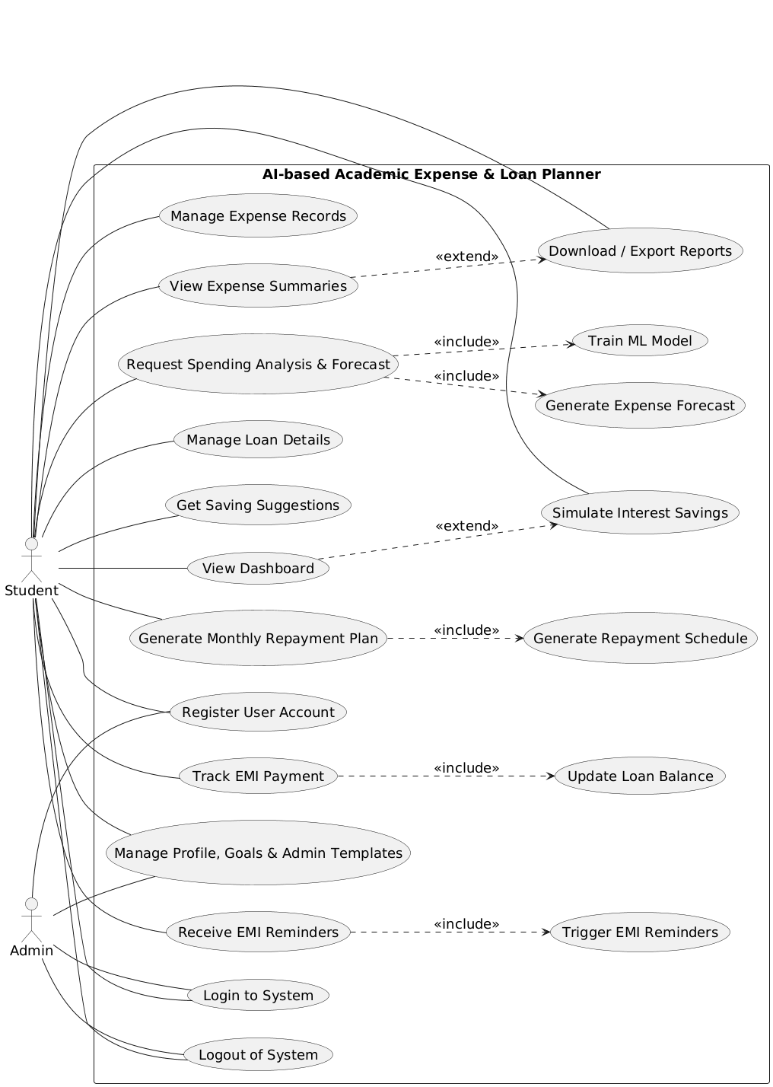
Figure.1 Use case diagram

2. Class Diagram
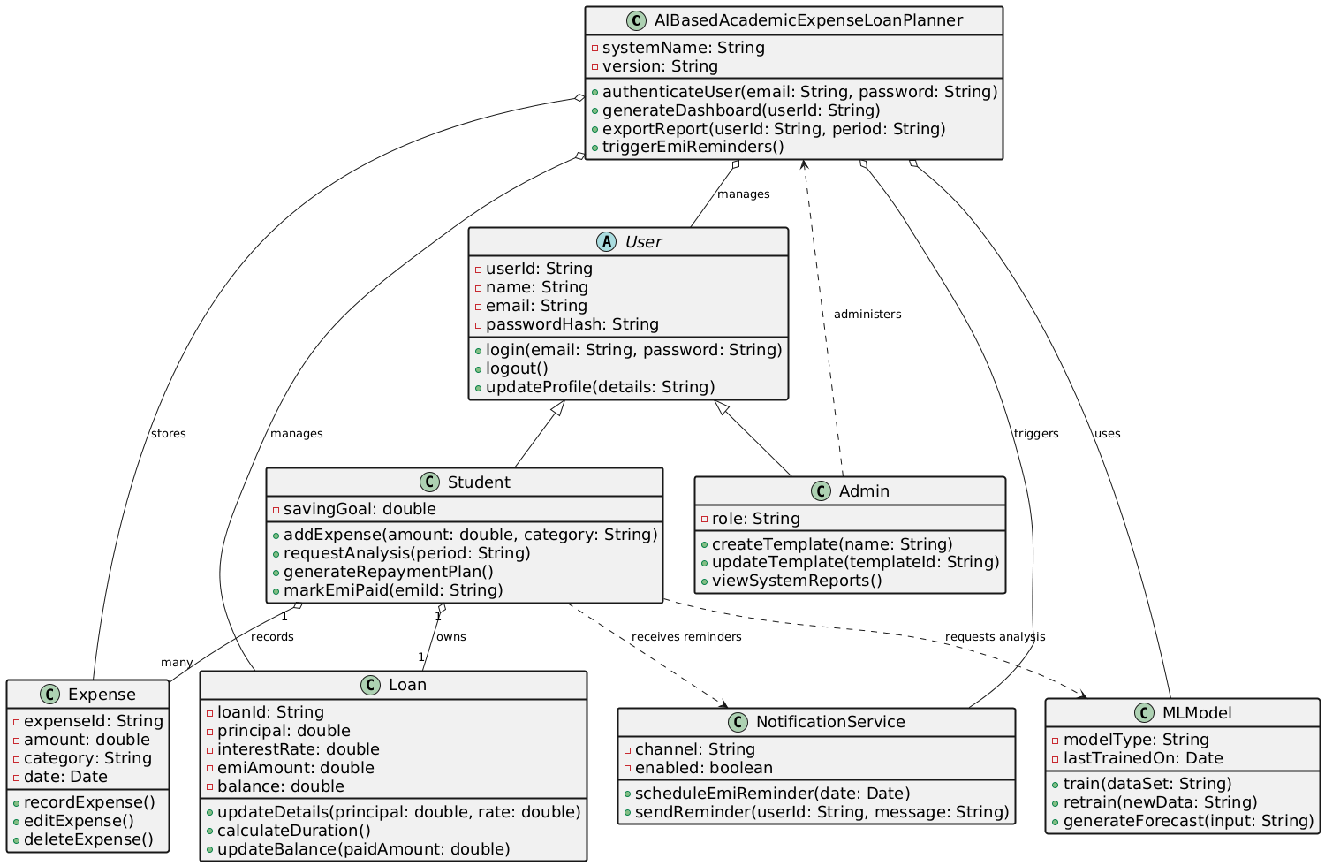
Figure.2 Class Diagram

3. Object Diagram
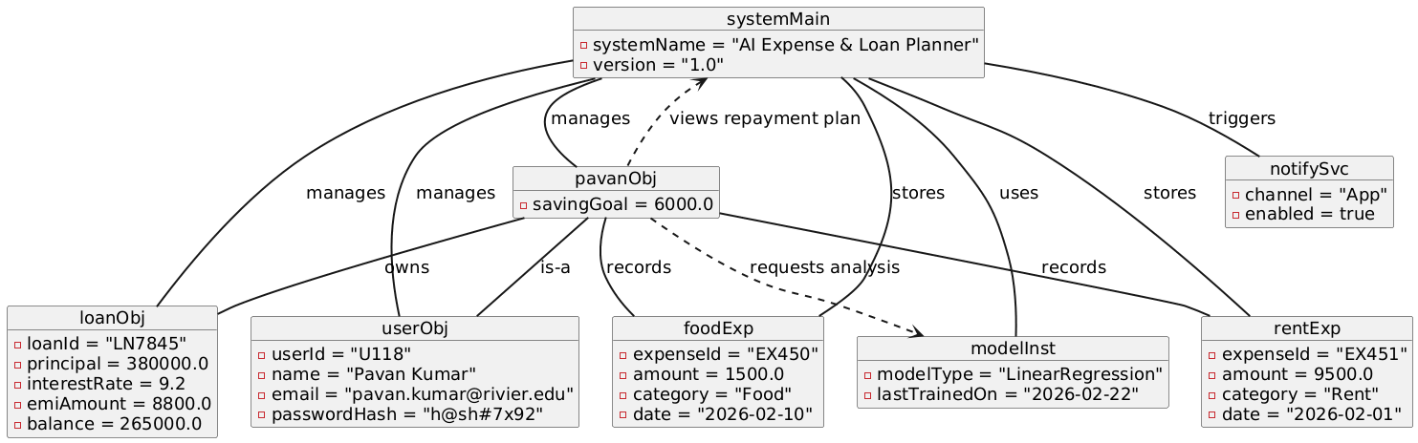Figure.3 Object Diagram

4. Sequence Diagram
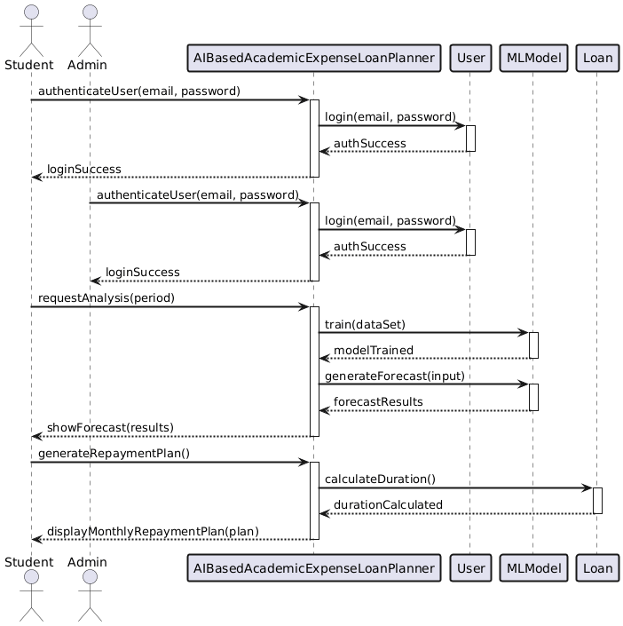
Figure.4 Sequence Diagram

5. Behavioural state machine diagram
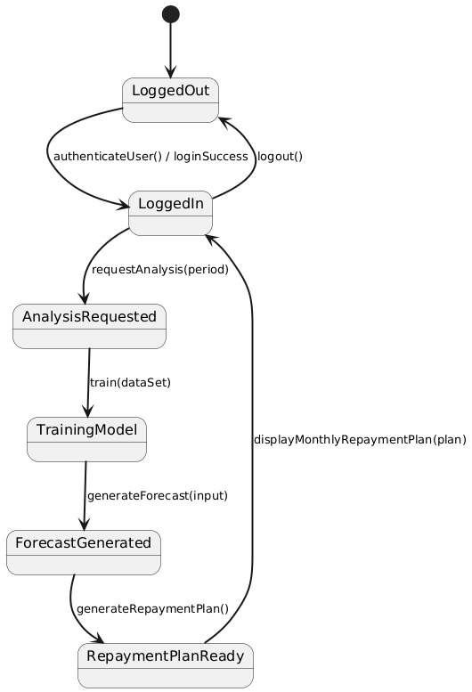
Figure.5 Behavioural State Machine Diagram

6. Mapping table: from use cases to class diagram
The functional model was used as the starting point to identify what the system must do. Each use case was reviewed to find the main nouns and actions. These nouns became classes in the structural model, such as User, Student, Loan, Expense, MLModel, and NotificationService. The system class (AIBasedAcademicExpenseLoanPlanner) was added to represent the application boundary and coordination logic. The class diagram shows how these classes are related, for example, a student owns a loan and records expenses.
The behavioral models were then created from the same use cases. The sequence diagram shows how objects interact when a student logs in, requests spending analysis, the model is trained, a forecast is generated, and a repayment plan is displayed. The state machine shows how the system moves through states during this flow. This approach keeps the structural and behavioral models consistent with the functional requirements.
Traceability Table:
Use Case # | Use Case Name | Classes Used (from Class Diagram)
UC-01 | Register User Account | AIBasedAcademicExpenseLoanPlanner, User
UC-02 | Login to System | AIBasedAcademicExpenseLoanPlanner, User
UC-03 | Logout of System | AIBasedAcademicExpenseLoanPlanner, User
UC-04 | Manage Expense Records | AIBasedAcademicExpenseLoanPlanner, Student, Expense
UC-05 | View Expense Summaries | AIBasedAcademicExpenseLoanPlanner, Student, Expense
UC-06 | Request Spending Analysis & Forecast | AIBasedAcademicExpenseLoanPlanner, Student, MLModel
UC-07 | Manage Loan Details | AIBasedAcademicExpenseLoanPlanner, Student, Loan
UC-08 | Get Saving Suggestions | AIBasedAcademicExpenseLoanPlanner, Student, MLModel
UC-09 | View Dashboard | AIBasedAcademicExpenseLoanPlanner, Student, Loan, Expense
UC-10 | Generate Monthly Repayment Plan | AIBasedAcademicExpenseLoanPlanner, Student, Loan
UC-11 | Track EMI Payment | AIBasedAcademicExpenseLoanPlanner, Student, Loan
UC-12 | Receive EMI Reminders | AIBasedAcademicExpenseLoanPlanner, NotificationService
UC-13 | Download / Export Reports | AIBasedAcademicExpenseLoanPlanner, Student, Admin
UC-14 | Simulate Interest Savings | AIBasedAcademicExpenseLoanPlanner, Student, Loan
UC-15 | Manage Profile, Goals & Admin Templates | AIBasedAcademicExpenseLoanPlanner, Student, Admin

